**Exercise-11**

**Q- Write HTML code to create a web page with a heading. The heading shall be displayed at top center of the page and the image shall be at the center,just below the heading.**

<!DOCTYPE html>

<html>

<head>

<title>Centered Heading and Image</title>

</head>

<body>

<h1 align="center"><i>cat</i></h1>

<center><img

src="https://res.cloudinary.com/dzdgpwtox/image/upload/w_450,c_scale,f_auto/v1696236076/final_designs/seller_design_514454/f_20231002084115.png"="cat"></center>

</body>

</html>

**Exercise-12**

**Q- Write HTML code using multimedia tags.**

<!DOCTYPE html>

<head>

<title>Multimedia Example</title>

</head>

<body>

<h1>Welcome to My Multimedia Page</h1>

<h2>Image Example</h2>

<img src="https://cdn.pixabay.com/photo/2018/01/14/23/12/nature-3082832_1280.jpg" alt="Placeholder Image"

width="600" height="400">

<h2>Audio Example</h2>

<audio controls>

<source src="https://www.soundhelix.com/examples/mp3/SoundHelix-Song-1.mp3" type="audio/mpeg">

Your browser does not support the audio tag.

</audio>

<h2>Video Example</h2>

<video width="600" height="400" controls>

<source src="https://www.w3schools.com/html/mov_bbb.mp4" type="video/mp4">

Your browser does not support the video tag.

</video>

</body>

</html>

**Exercise-13**

**Create a table using rowspan and colspan taking examples of student**

**records.**

<!doctype html>

<html>

<head>

<title> Rowspan and colspan</title>

</head>

<body>

<h2>Student Records</h2>

<table border="5">

<tr>

<th rowspan="2">Student ID</th>

<th rowspan="2">Name</th>

<th colspan="3">Subjects</th>

</tr>

<tr>

<th>Python</th>

<th>WAD</th>

<th>LAST</th>

</tr>

<tr>

<td>1</td>

<td>Ansh sharma</td>

<td>86</td>

<td>91</td>

<td>87</td>

</tr>

<tr>

<td>2</td>

<td>Harsh</td>

<td>93</td>

<td>94</td>

<td>88</td>

</tr>

<tr>

<td>3</td>

<td>shivam</td>

<td>88</td>

<td>84</td>

<td>81</td>

</tr>

<tr>

<td>4</td>

<td>peyush</td>

<td>82</td>

<td>87</td>

<td>86</td>

</tr>

</table>

</body>

</html>

**Exercise-14**

**Write HTML code using table tag <table> and cell padding and cell spacing as**

**its attributes.**

<!doctype html>

<html>

<head>

<title>table tags</title>

</head>

<body>

<h2>Student Records</h2>

<table border="1" cellpadding="10" cellspacing="5">

<tr>

<th>Student ID</th>

<th>Name</th>

<th>WAD</th>

<th>Python</th>

<th>LAST</th>

</tr>

<tr>

<td>1</td>

<td>Ansh sharma</td>

<td>85</td>

<td>90</td>

<td>88</td>

</tr>

<tr>

<td>2</td>

<td>harsh</td>

<td>92</td>

<td>95</td>

<td>89</td>

</tr>

<tr>

<td>3</td>

<td>shivam</td>

<td>78</td>

<td>84</td>

<td>80</td>

</tr>

<tr>

<td>4</td>

<td>peyush</td>

<td>82</td>

<td>88</td>

<td>85</td>

</tr>

</table>

</body>

</html>

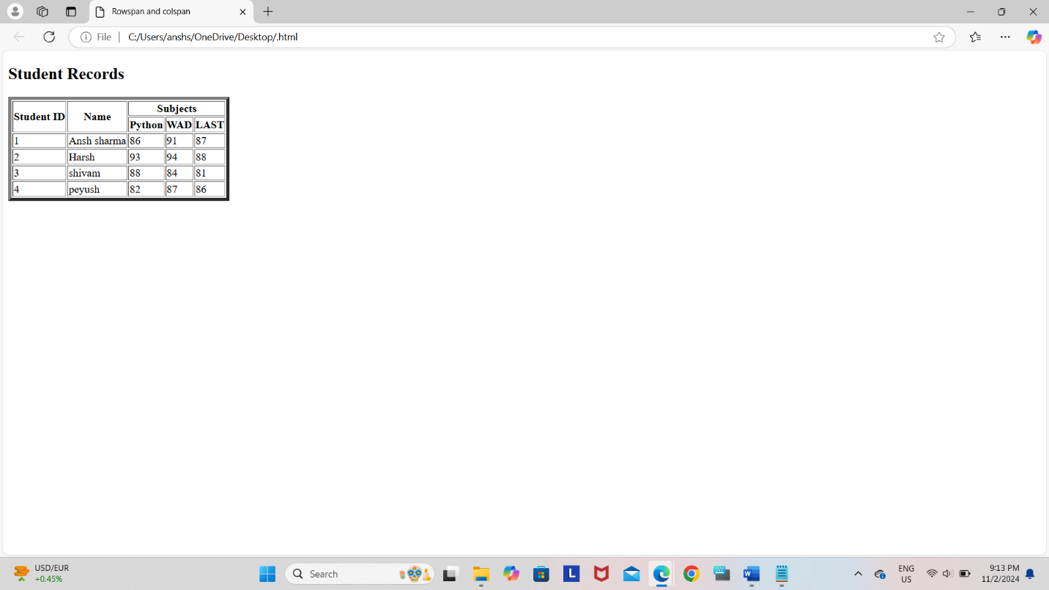

**Exercise-15**

**Write unordered,ordered and definition list taking emaxple of your subjects**

**in MCA 1st ,2nd and 3rd semester**.

<!DOCTYPE html>

<html>

<head>

<title>MCA Subjects</title>

</head>

<body>

<h1 style="color:blue;">MCA Subjects</h1>

<h2>1st Semester Subjects</h2>

<ul>

<li>Mathematics I</li>

<li>web technology</li>

<li>Programming in C</li>

<li>Communication Skills</li>

</ul>

<h2>2nd Semester Subjects</h2>

<ol>

<li>Mathematics II</li>

<li>web technology</li>

<li>Database Management Systems</li>

<li>IKS</li>

</ol>

<h2>3rd Semester Subjects</h2>

<dl>

<dt>Data base management:</dt>

<dd>Study of operating system concepts and structures.</dd>

<dt>Web Technologies:</dt>

<dd>Introduction to web development and related technologies.</dd>

<dt>c Programming:</dt>

<dd>Principles of OOP using languages like Java.</dd>

<dt>Computer Networks:</dt>

<dd>Overview of networking concepts and protocols.</dd>

</dl>

</body>

</html>

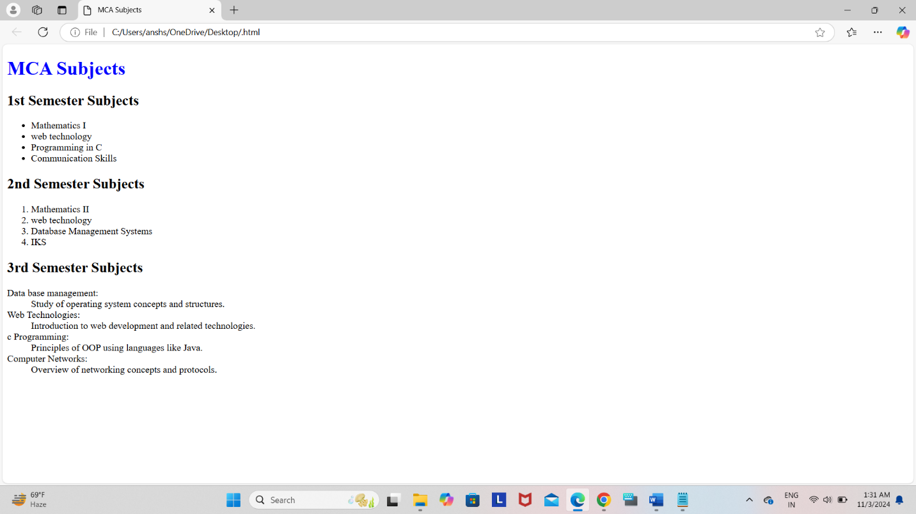

**Exercise-17**

**Write HTML code to design a form in HTML using controls and buttons such**

**as textbox,text area, password,submit button,browse button,drop-down**

**menu.**

<!DOCTYPE html>

<html>

<head>

<title>password Form</title>

</head>

<body>

<form action="/submit_form" method="post"><fieldset><legend>Login Page</legend>

<label for="username">Username:</label><br>

<input type="text" id="name" name="name"><br><br>

<label for="password">Password:</label><br>

<input type="password" id="password" name="password"><br><br>

<label for=" leave a comments"> Leave a Comments:</label><br>

<textarea id="other" name="comments" rows="4" cols="50"></textarea><br><br>

<label for="file">Upload a file:</label><br>

<input type="file" id="file" name="file"><br><br>

<label for="country">Country:</label><br>

<select id="country" name="country">

<option value="india">India</option>

<option value="us">United States</option>

<option value="uk">United Kingdom</option>

<option value="canada">Canada</option>

</select><br><br>

<input type="submit" value="Submit">

</form>

</body>

</html>

**Exercise-18**

**Write HTML code to design a registration form in HTML.**

<!doctype html>

<html>

<head><title>Registration Form</title></head>

<body>

<h2 style="color:red;" align="center">Registration Form</h2>

<form action="/submit_registration" method="post"><fieldset>

<label for="firstname">First Name:</label>

<input type="text" id="firstname" name="firstname" required><br><br>

<label for="lastname">Last Name:</label>

<input type="text" id="lastname" name="lastname" required><br><br>

<label for="email">Email:</label>

<input type="email" id="email" name="email" required><br><br>

<label for="password">Password:</label>

<input type="password" id="password" name="password"required><br><br>

<label for="gender">Gender:</label>

<select id="gender" name="gender">

<option value="male">Male</option>

<option value="female">Female</option>

<option value="other">Other</option>

</select><br><br>

<label for="bio">Bio:</label><br>

<textarea id="bio" name="bio" rows="4" cols="50"></textarea><br><br>

<label for="profilepic">Profile Picture:</label>

<input type="file" id="profilepic" name="profilepic"><br><BR>

<label for="signature">Signature:</label>

<input type="file" id="sign" name="signature">

<center><button>Register</button>

<button> reset</button></center>

</form>

</body>

</html>

**Exercise-19**

**Write HTML code to design a registration form in HTML.**

<!doctype html>

<html>

<head><title>Registration Form</title></head>

<body>

<h2 style="color:red;" align="center">Registration Form</h2>

<form action="/submit_registration" method="post"><fieldset>

<label for="firstname">First Name:</label>

<input type="text" id="firstname" name="firstname" required><br><br>

<label for="lastname">Last Name:</label>

<input type="text" id="lastname" name="lastname" required><br><br>

<label for="email">Email:</label>

<input type="email" id="email" name="email" required><br><br>

<label for="password">Password:</label>

<input type="password" id="password" name="password"required><br><br>

<label for="gender">Gender:</label>

<select id="gender" name="gender">

<option value="male">Male</option>

<option value="female">Female</option>

<option value="other">Other</option>

</select><br><br>

<label for="bio">Bio:</label><br>

<textarea id="bio" name="bio" rows="4" cols="50"></textarea><br><br>

<label for="profilepic">Profile Picture:</label>

<input type="file" id="profilepic" name="profilepic"><br><BR>

<label for="signature">Signature:</label>

<input type="file" id="sign" name="signature">

<center><button>Register</button>

<button> reset</button></center>

</form>

</body>

</html>

**Exercise-20**

**Create a proper home page of your own using any components and style**

<!DOCTYPE html>

<html>

<head>

<title>My Homepage</title>

<link rel="stylesheet" href="C:\Users\ansh

\OneDrive\Desktop\Bsc(IT)\html\body.css">

</head>

<body>

<header>

<h1>Welcome to My Homepage</h1>

</header>

<p class="ansh">

<section class="about">

<h2>About Me</h2>

<p>Hello! I'm ansh my age is 18.</p>

</section>

<section id="services">

<h2>Services</h2>

<p>All kind of mobile service are avaible.</p>

</section>

<section id="contact">

<h2>Contact Me</h2>

<p>You can reach me at ansh090@gmail.com .</p>

</section>

</body>

</html>

**Exercise-21**

**Write HTML code including local hyperlinking in a web page**

<!DOCTYPE html>

<html>

<head>

<title>Local Hyperlink Example</title>

</head>

<body>

<h1>Welcome to My Web Page</h1>

<p><a href="#ABDUL1">Go to pakistan 1</a></p>

<p><a href="#ABDUL2">Go to pakistan 2</a></p>

<h2 id="ABDUL1">Section 1</h2>

<p>This is the content of ABDUL1.</p>

<p><a href="#top">Back to Top</a></p>

<h2 id="section2">ABDUL2</h2>

<p>This is the content of ABDUL 2.</p>

<p><a href="#top">Back to Top</a></p>

</body>

</html>

**Exercise-22**

**Write HTML code including inter hyperlinking in a web page.**

<!DOCTYPE html>

<html>

<head>

<title>Inter Hyperlink Example</title>

</head>

<body>

<h1>Welcome to My Web Page</h1>

<p><a href="https://www.youtube.com/watch?v=TU1HQnU_9ME&pp=ygUJa2FyYW4gYXVq">Visit this to listen karan aujla </a></p>

<p><a href="https://www.youtube.com/watch?v=6xoB4ZiKKn0&pp=ygUQc2lkaHUgbW9vc2Ugd2FsYQ%3D%3D">Visit for sidhu moose wala </a></p>

</body>

</html>

**Exercise-23**

**Write HTML code for including external hyperlinking in a web page.**

<!DOCTYPE html>

<html>

<head>

<title>External Hyperlink </title>

</head>

<body>

<h1>Welcome to My Web Page</h1>

<p>Check out this <a href="https://www.youtube.com/@sonymusicindiaVEVO"

target="_blank">music video</a>!</p>

</body>

</html>

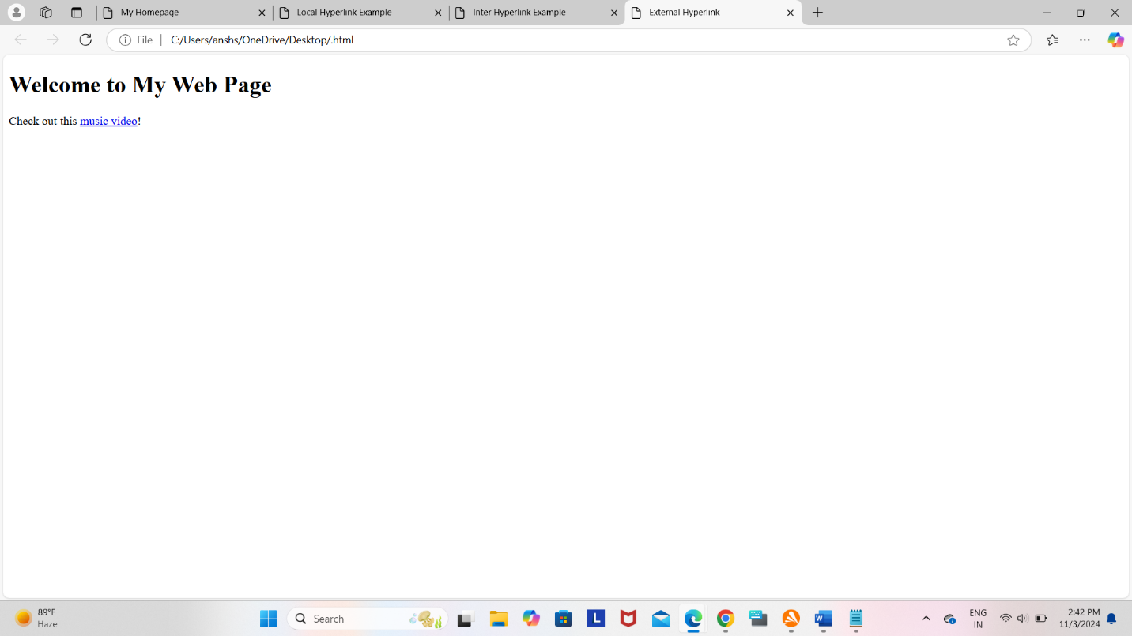

**Exercise-24**

**Write code to show External CSS with HTML code.**

**External CSS code:**

p{color: chocolate; font-size: larger;}

h1{text-align: center;}

#para1{text-align: left; color:darkgreen; font-size: 50px;}

#para2{text-align: center; color:blue;font-size: medium; font-style: italic;}

.ansh{text-align: center;color: green;}

h2,h3,b,i{font-family:'Gill Sans', 'Gill Sans MT', Calibri, 'Trebuchet MS', sans-serif; color:navy;}

**HTML code:**

<!DOCTYPE html>

<html>

<head>

<title>para</title>

<link rel=stylesheet href="C:\Users\ansh\OneDrive\Desktop\bca\CSS\stylesheet para.css">

</head>

<body>

<h1>This is para stylesheet with different id's</h1>

<p>CSS</p>

<p id="para1"> This is para1 </p>

<p id="para2">This is para2</p>

<p class="ansh">This is .ansh selector</p>

<h2>ansh</h2>

<h3>sharma</h3>

<b>manav rachna</b><br>

</body>

</html>

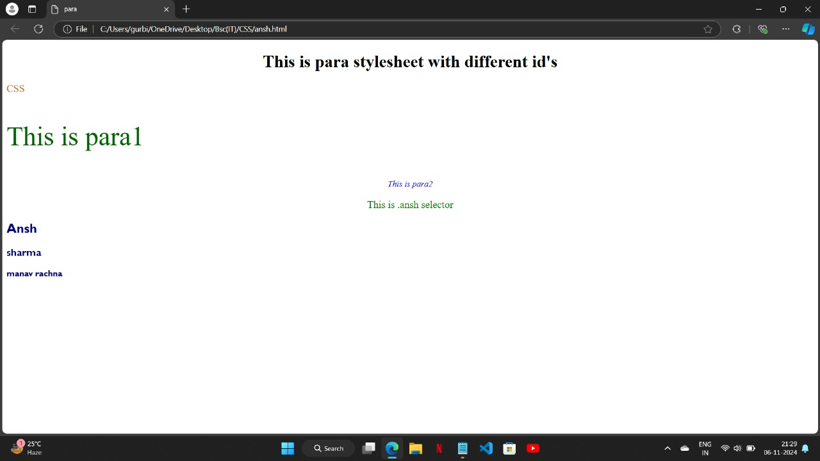

**Exercise-25**

**Write code to show Internal CSS with HTML code.**

<!doctype>

<html>

<head><title> internal CSS

</title>

<style>

body {background-color:blue;}

p {color:black; font-size: 440%;}

h1{color:red; font-size: 450%;}

h2{color:green; font-size:400%}

</style>

</head>

<body>

<p> This paragraph for CSS</P>

<h1>html</h1>

<h2>CSS</h2>

</body>

</html>

**Exercise-26**

**Write code to show inline CSS with HTML code.**

<!DOCTYPE html>

<html lang="en">

<head>

<title>Inline CSS Example</title>

</head>

<body>

<h1 style="color:black; font-family: Arial, sans-serif;">Welcome to My Web Page</h1>

<p style="color:green; background-color:orange; padding: 10px;">This is abdul badmash CSS.</p>

</body>

</html>

